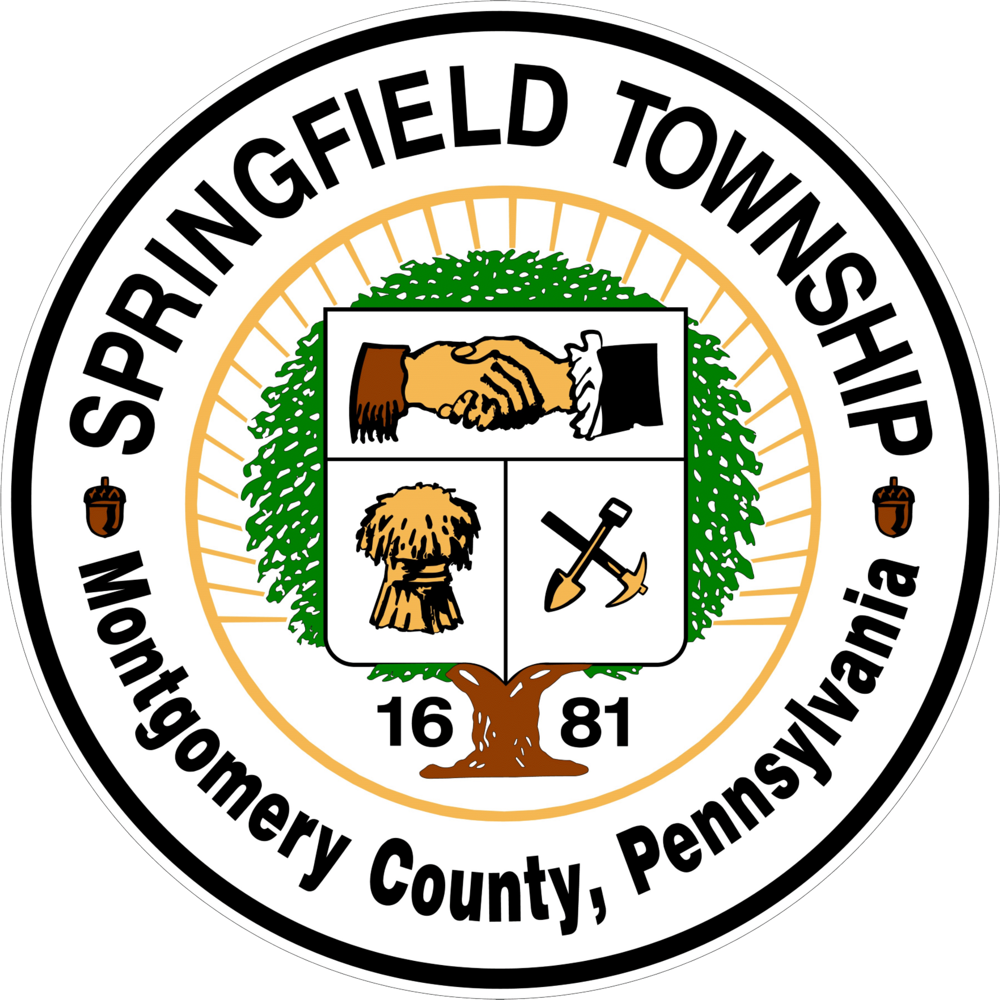
Springfield Township
Historical Commission Meeting
July 7, 2026

Please be aware that this meeting has a 6:00 PM start time. The meeting is held in the large conference room of the Township Administration Building, located at 1510 Paper Mill Road, Wyndmoor, PA 19038.

Notice: The Historical Commission of Springfield Township is an advisory board appointed by the Board of Commissioners. The actions of the Historical Commission on any agenda item does not reflect a final decision. The Board of Commissioners must render the final decision on all agenda items.

Call To Order:

Roll Call: Ruthrauff Harris Devine
Standish Comly Sands

Meeting Minutes: Review the minutes of May 5, 2026, meeting.

Commissioner’s Report:

Agenda Items:

HC1: The Historical Commission will discuss the response to the May 7, 2026, memo sent to the Township Manager concerning recommendations to prepare a list of properties within the Township of historical interest, historical importance and/or that contain historical features. In addition, they will discuss their request for the hiring of a consultant.

HC2: The Historical Commission will discuss their recommendation to amend Chapter 46 to include incentives for commercial properties of historical interest.

HC3: The Historical Commission will continue their discussion of extending the meetings to 90 minutes, with a 5:30 p.m. start time or selecting another night to hold their meetings.

HC4: The Historical Commission will discuss their recommendation to repeal the Historical Preservation Ordinance.

Adjourned:

